EXPT NO:4 | Visual encoding of data
DATE: 20.01.2026 | Visual encoding of data

PRE-LAB QUESTIONS
1.How does the human visual system process visual variables?

The human visual system processes visual variables such as color, size, shape, position, and intensity in parallel. These variables are quickly perceived without conscious effort, allowing humans to identify patterns, trends, and anomalies rapidly. Position and length are perceived most accurately, followed by color and shape.

2.Why is improper encoding misleading in analytics?

Improper encoding can distort the meaning of data by exaggerating or hiding important patterns. For example, using incorrect color scales or misleading sizes may lead to wrong conclusions and poor decision-making. This can cause analysts and policymakers to misunderstand the true insights in the data.

3.What are perceptual limitations in visualization?

Perceptual limitations refer to the constraints of human vision, such as difficulty in distinguishing similar colors, accurately comparing areas or volumes, and remembering multiple visual elements at once. These limitations can reduce clarity and increase cognitive load if visualizations are not designed carefully.

4.How does color choice affect interpretation?

Color choice strongly influences interpretation by guiding attention and conveying meaning. Warm colors like red indicate high intensity or danger, while cool colors like blue suggest low intensity or calmness. Poor color choices or non-uniform color scales can confuse viewers or misrepresent data values.

5.Why should AI dashboards be perceptually optimized?

AI dashboards should be perceptually optimized to ensure insights are easily understandable, trustworthy, and actionable. Proper visual encoding reduces cognitive effort, improves explainability, and helps users make accurate decisions based on AI outputs. This is especially important for real-time and high-stakes applications.

OBJECTIVE: To apply effective visual encoding principles for meaningful data communication.

SCENARIO: A city traffic department analyzes accident data to identify high-risk zones and accident severity patterns.

IN-LAB TASKS (Using R Language)

1.Encode severity using color gradients

Code:

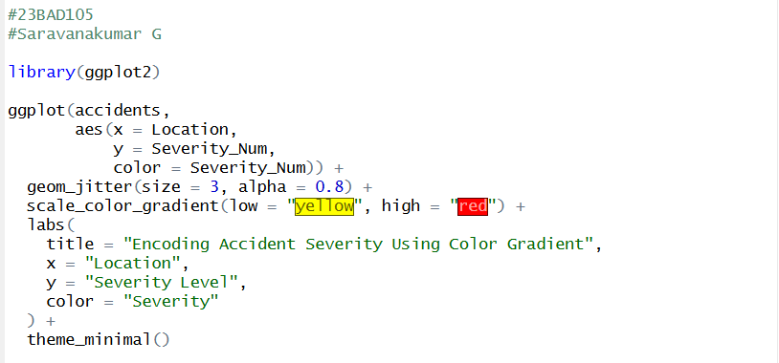

Output:

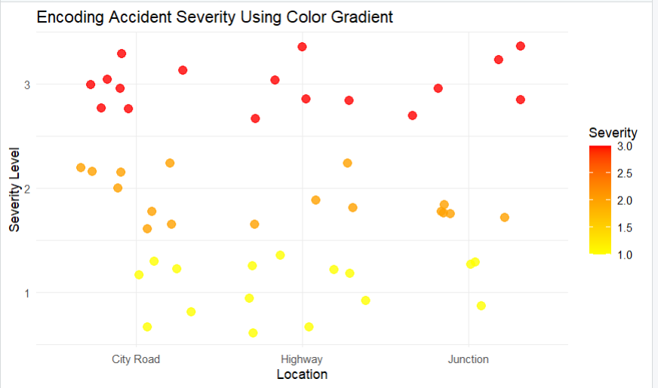

2.Represent accident frequency using size

Code:
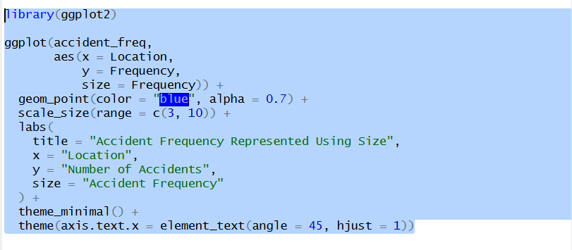

Output:
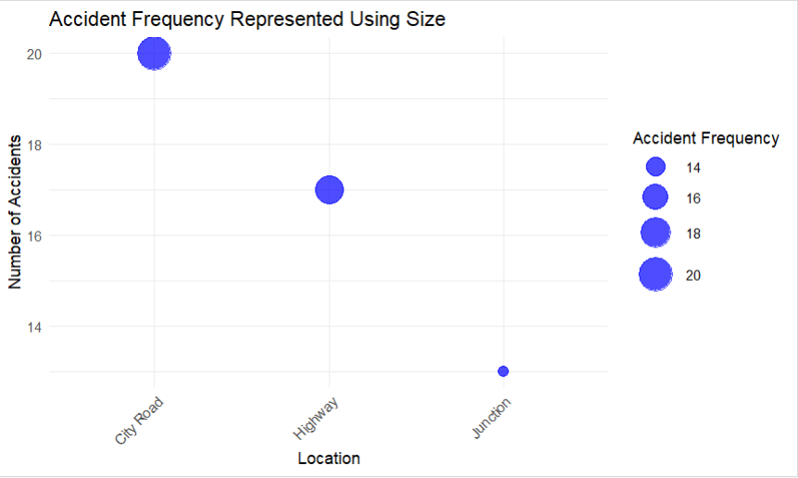
3. Use shape to indicate accident type
Code:
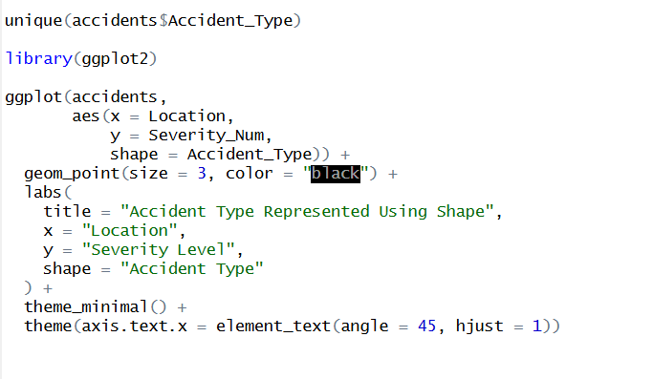

Output:
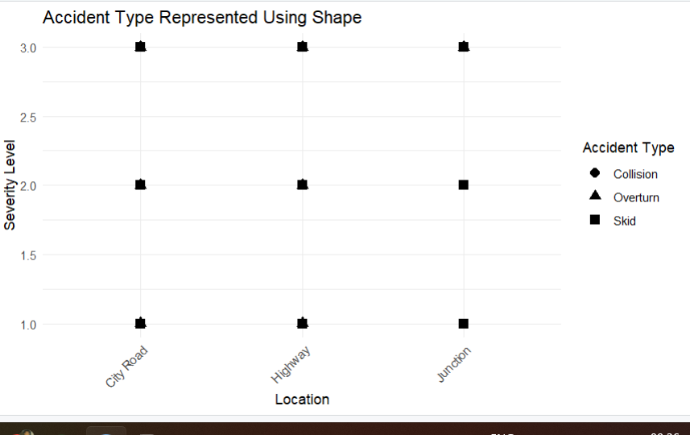

POST-LAB QUESTIONS

1.Which visual variable best conveys severity and why?

Color intensity is the best visual variable to convey severity because humans quickly associate darker or more intense colors with higher risk or danger. Color gradients allow viewers to easily compare severity levels at a glance.

2.How can poor encoding mislead policy decisions?

Poor encoding can hide critical patterns or exaggerate minor issues, leading to incorrect interpretations. Policymakers may allocate resources incorrectly or ignore high-risk areas due to misleading visual representations.

3.What precautions should be taken for color-blind users?

Color-blind safe palettes should be used, avoiding red-green combinations. Redundant encoding such as shape, size, or labels should be included to ensure information is accessible to all users.

4.How does visual encoding affect AI explainability?

Effective visual encoding improves AI explainability by clearly showing how inputs and outputs relate. Transparent and intuitive visuals help users understand AI decisions, increasing trust and usability.

5.Suggest improvements for large-scale public dashboards.

Large-scale public dashboards should use simple layouts, consistent color schemes, clear legends, and interactive filters. Visual clutter should be minimized, and accessibility features should be included for diverse users.

LEARNING OUTCOME: Students learn perceptually effective visual communication for AI systems.

ASSESSMENT
Description | Max Marks | Marks Awarded
Pre Lab Exercise | 5
In Lab Exercise | 10
Post Lab Exercise | 5
Viva | 10
Total | 30
Faculty Signature

